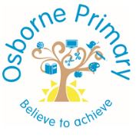
Osborne Primary School
Whole School Curriculum
2024-2025

Year 1 Overview
 | Autumn |  | Spring |  | Summer
Literacy  Writing, Reading and SPAG | 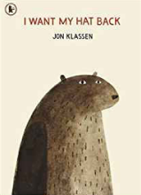 | Extended narrative  3 week unit | 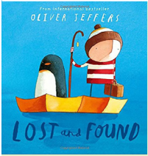 | Extended narrative  3 week unit | 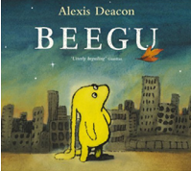 | Science fiction  2 week unit
 | 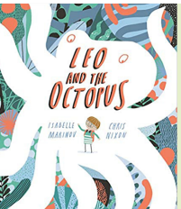 | Non-chronological report  3 week unit | 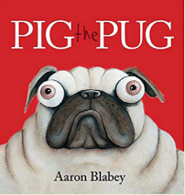 | Explanation text  3 week unit | 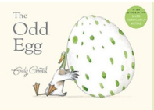 | Non-chronological report  2 week unit
 | 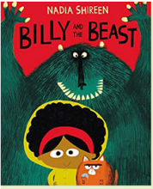 | Adventure narrative  3 week unit | 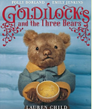 | Whole School  3 week unit  Fairytales | 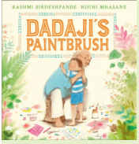 | Story from another culture  3 week unit
 | 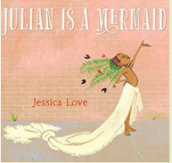 | Poetry  2 week unit |  |  | 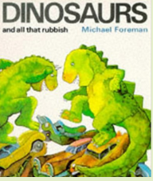 | Persuasive writing  2 week unit
 |  | Whole School  2 week unit  Fantasy |  |  | 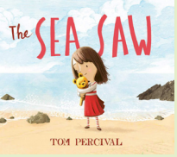 | Narrative from other perspective  3 week unit
 |  |  |  |  | 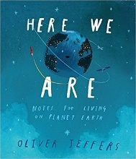 | 2 week unit  Whole school  Community
Maths | Place Value (Within 10) | Addition and Subtraction  (Within 10)  Geometry | Place Value  (within 20)  Addition and Subtraction  (within 20) | Place Value  (within 50)  Length and height | Mass and Volume  Multiplication and Division  Fractions | Position and Direction  Place value  (within 100)  Money  Time

 |  | Autumn 1 | Autumn 2 | Spring 1 | Spring 2 | Summer 1 | Summer 2
Science |  | My Body My senses | Celebrations: Light, music and food | Polar Place: animals and food | Plants and Animals where I live | On Safari: Minibeasts | Holiday:
Geography |  | Countries and capitals of the UK |  | Small area study of the UK |  | Seasonal and daily weather of the UK
History |  | Toys |  | Significant women  Mary Seacole & Florence Nightingale |  | Local History study: 100 Years in Erdington
Religious Education |  | Creating Inclusion, Identity & Belonging, Being thankful, Being Modest, Expressing Joy |  | Being fair and just, Being accountable, Being courageous, Being Loyal |  | Remembering Roots, Being hopeful, Being curious, Being open & honest
Physical Education |  | Invasion games skills | Net and wall game skills | Gymnastics:  Spinning on points and patches | Gymnastics: pathways small and long | Striking and fielding | Athletics
Art and Design |  | Painting: colour mixing  Kandinsky, Jasper Johns, Paul Klee |  | Printing: press, roll to make stamps  William Morris |  | Collage: materials cut, torn and glued  Arcimboldi, Rousseau
Design Technology |  | Mechanisms: Sliders and levers |  | Structures: Freestanding structures |  | Food: Preparing fruit and vegetables
Computing | CS | Barefoot Algorithms | Knock, knock  Scratch Junior | Bee Bot Treasure Hunters |  |  | Beginning to Code
 | DL |  |  |  | Data | Technology around us
 | OS | Penguin Pig | Hectors World 1 &2 | Hector’s World 3 & 4 | Monkey Cow | Hectors world 5 & 6 | Jessie and Friends 1, 2 & 3
 | IT | Create drawing:  word art | Create photo: Everyday objects | Create drawing:  Still life | Create film:  My first Film | Animate: Book 1 Challenge 1 | Create Publishing Project
Music |  | Pulse and Rhythm | Dynamics and tempo | Musical vocabulary | Timbre and rhythmic patterns | Pitch and tempo | Vocal and body sounds
PSHE and RSE |  | Ground rules, family and relationships 1, 2, 3, 5, 6, 7  PCSO inputs | Health and Well Being 1, 3, 5, 8  Anti bullying week – building relationships 2  Road Safety week | Safety and the changing body 1, 2, 3, 4, 5, 8  Children’s mental health awareness week | Citizenship 1, 3, 4, 5  PCSO Input | Economic wellbeing 1, 2, 3, 4, 5, 6  Mental health awareness week – health and wellbeing L1 | Health and wellbeing 6, 7  Family and relationships L4, 6  PCSO  Transition
No Outsiders |  |  | Elmer: liking the way I am | Ten Little Pirates: I can play with girls and boys | My Grandpa is Amazing: Recognise people are different ages | Max the Champion:  bodies work in different ways | My World: We share the world with lots of people
Safeguarding |  | What is a respectful friendship? | What is a disrespectful friendship? | What is crime? |  | How do medicines help me? | When is it safe to take medicines?
Enrichment |  | Anti-bullying week  Black History Month  Pantomime  World Children’s Day  Church visit- St Barnabas  Black country living museum Toys from the past |  | Mental Health and Wellbeing Week  Science Week  Easter workshops at Erdington Baptist Church  Wildlife Trust – animals of Birmingham and the Black country |  | Aspirations Week  My Money Week  Art Week  Visit to a Mandir
Parent/Carer Engagement

Year 2 Overview
 | Autumn |  | Spring |  | Summer
Writing | 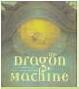 | 3 week unit  Myths/Legends | 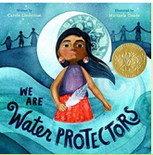 | 3 week unit  Persuasive writing | 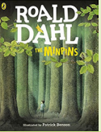 | 3 week unit  Adventure narrative
 | 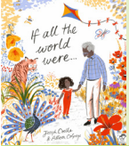 | 2 week unit  Non-Narrative poetry | 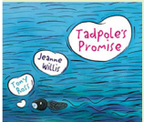 | 3 week unit  Extended narrative | 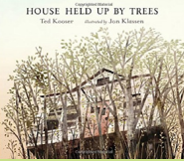 | 3 week unit  Non-chronological report
 | 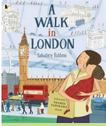 | 3 week unit  Recount | 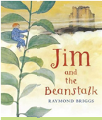 | Whole School  3 week unit  Fairytales | 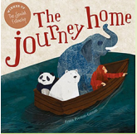 | 3 week unit  Persuasive writing
 | 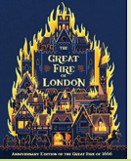 | 3 week unit  Explanation text |  |  | 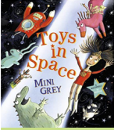 | 3 week unit  Science fiction
 | 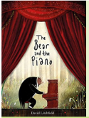 | 3 week unit  Own version narrative |  |  |  | 2 week unit  Whole school  Community
Whole School
2 week unit
Fantasy

Maths | Place Value | Addition and Subtraction  Shape | Money  Multiplication and Division | Multiplication and Division  Length and height and mass | Capacity and temperature  Fractions  SATS window | Fractions  Time  Statistics

 |  | Autumn 1 | Autumn 2 | Spring 1 | Spring 2 | Summer 1 | Summer 2
Science |  | Healthy me | Materials Monster | Squash, squeeze, bend and twist | Our local environment: habitats | Young gardeners | Little Masterchefs
Geography |  | Countries and Oceans of the World |  | Small area Study of Kenya |  | Locations of hot and cold countries of the world
History |  | The Great Fire of London |  | The Gunpowder Plot |  | Significant people: Wright brothers & Amy Johnson
Religious Education |  | Living by rules, Being temperate, Responding to suffering, Sharing. |  | Creating unity and harmony, Participating & willing to lead, caring for others, Being merciful |  | Being attentive, being reflective, Being imaginative, Appreciating beauty
Physical Education |  | Invasion Game Skill | Net and Wall games | Gymnastics: spinning, turning, twisting | Gymnastics: stretching, curling and arching | Striking and Fielding 2 | Athletics 2
Art and Design |  | Textiles: paper, straws, card and clay  Great Fire of London |  | Sculpture: using glue or stitch and weaving for pattern  Andy Goldsworthy, Louise Bourgeois |  | Digital Media: create different texture, lines, colours, tones and shapes  David Hockney
Design Technology |  | Mechanisms: Wheels and axles |  | Food: Preparation fruit vegetable |  | Textiles: Templates and joining techniques
Computing | CS |  | Scratch Astronauts | Learn to code 1 |  |  | Learn to code 2
 | DL | Information Technology
 | OS | Be internet legends: Sharp 1 | Be Internet legends:  Sharp 2 | Be Internet Legends Sharp 3 | Internet legends Sharp 4 | Internet Legends Sharp 5 | Be Internet Legends: Alert 1
 | IT | Create drawing: Observational drawing | Create Photo: Potraits | Create Music: Live loops | Create Film: Silent film | Animate: Book 1 Challenge 1 | Create Publishing Project
Music |  | West African call and response song | Orchestral instruments | Musical me: tuned percussion | Dynamics, timbre, tempo and motifs | On this Island, British songs | Myths and legends
PSHE and RSE |  | Ground rules, family and relationships 2, 4, 5, 6, 7,  PCSO inputs | Health and well being 1, 2, 4, 5, 6  Anti bullying week  Road safety week – safety and the changing body L7 | Safety and the changing body 1, 2, 3, 4, 5, 6  Mental health awareness week | Citizenship 1, 2, 5, 7  PCSO inputs | Economic wellbeing 1, 2, 3, 4,  Mental health awareness week – health and wellbeing L2 | Economic wellbeing 5, 6  Health and wellbeing 3  PCSO inputs  Transition
Safeguarding |  | How can I deal with peers being unkind to me or even hurting me? | How do I show respect for others? | What should I do if someone is committing a crime? | What support can I get for reporting a crime? | Who should advise me and help me take medicines?
No Outsiders |  | The Great Big Book of Families:  Understand diversity | The first Slodge:  Understand how we share the world | The odd Egg: Understand what makes someone feel proud | Just Because: to feel proud of being different | Blown Away: to be able to work with everyone in my class | Transition module
Enrichment |  | Anti-bullying week  Black History Month  Pantomime  World Children’s Day  Great Fire of London drama workshop |  | Mental Health and Wellbeing Week  Science Week  Easter workshops at Erdington Baptist Church  Visit to a Mosque |  | Aspirations Week  My Money Week  Art Week  Mosque visit – Masjid Al Falaah  Trip to a local restaurant
Parent/Carer Engagement

Year 3 Overview
 | Autumn 1 | Autumn 2 | Spring 1 | Spring 2 | Summer 1 | Summer 2
Reading

Writing | 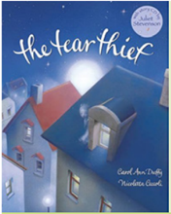 | 2 week unit  Explanation text | 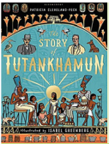 | 3 week unit  Biography | 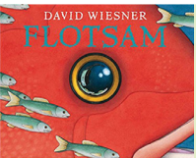 | 3 week unit  Science fiction
 | 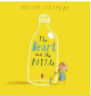 | 3 week unit  Extended narrative | 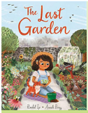 | 3 week unit  Extended narrative | 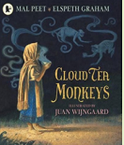 | 3 week unit  Non-chronological reports
 | 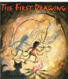 | 2 week unit  Historical narrative | 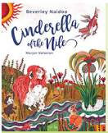 | Whole School  3 week unit  Fairytales | 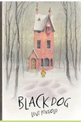 | 3 week unit  Mystery narrative
 | 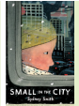 | 3 week unit  Narrative from alternative |  |  | 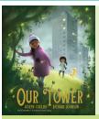 | 3 week unit  Extended fantasy narrative
 | 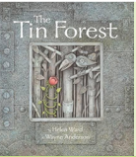 | 2 week unit  Persuasive writing |  |  |  | 2 week unit  Whole school  Community
Whole School
2 week unit
Fantasy
Maths

 |  | Autumn 1 | Autumn 2 | Spring 1 | Spring 2 | Summer 1 | Summer 2
Science |  | Rocks, soils and fossils | Food and our bodies | Light and Shadows | How does your garden grow? | Forces and magnets | Science in action: The nappy challenge
Geography |  | Counties and cities of the UK |  | Changes to settlement Type, patterns and land use over time |  | Volcanoes and Earthquakes  Case study Turkey
History |  | Stone Age  Iron Age |  | Ancient Egypt |  | Ancient Greece
Religious Education |  | Sharing and being generous, Caring for others, creating harmony, participating |  | Being fair & just, Being accountable, Remembering roots, Being loyal |  | Being honest, Being attentive, Being courageous, Being hopeful
Physical Education |  | Basketball | Dodgeball | Gymnastics linking movements | Receiving body weight | Tennis | Athletics
Art and Design |  | Digital Media: use images, video and sounds  Henri Rousseau, Oenone Hammersley |  | Painting: create mood with colour  Rothko, Picasso |  | Printing: Blocks and layers of two or more colours  Cave Art
Design Technology |  | Structure: Shell structures using CAD |  | Food: Healthy and varied diet |  | Textiles: 2d shape to 3D product
Computing | CS |  |  |  | Sphero 1 | Learn to code 3
 | DL | Connecting Computers | Data |  |  |  | Lego WeDo 2
 | OS | Be Internet Legends: Alert 2 | Be Internet Legends:  Alert 3 | Be Internet Legends: Secure 1 |  | Be Internet Legends: Secure 2 | Be Internet Legends Alert 1
 | IT | Create Drawing: portraits | Create Photo: Scenes | Create Music: Song composition | Create Film: Animatics | Animate: Book 2 Challenge 2 | Create Publishing Project
Music |  | Ballads | . creating composition in response to animation | Developing singing techniques | Pentatonic melodies and composition | Jazz and traditional instruments | Improvisation
French |  | Where is France? | Y3 Mastery Conversation | French Food |  | Restaurants and cafes
PSHE and RSE |  | Setting ground rules  Family and relationships1, 2, 3, 5, 6, 7 | Health and wellbeing 1, 3, 4, 5, 6  Antibullying week – family and relationships L7  Road safety week – safety and the changing body L8 | Economic wellbeing 1, 2, 4, 5  Mental health awareness – health and wellbeing L6 | Citizenship 1, 2, 3, 5  PCSO inputs | Safety and the changing body 1, 2, 3, 4, 5, 6, 7  Mental health awareness week | Citizenship 4, 6, 7  PCSO inputs  Transition
Safeguarding |  | How do I protect my body from others? |  | Is it ever okay for someone to touch me on my body? |  | What is a weapon?
No Outsiders |  | Oliver: understand how difference can effect someone | This is our House: Understand what discrimination means | Two Monsters: to find a solution to a problem | The Hueys in the New Jumper: Use strategies to help someone who feels different | Beegu: To be welcoming | Transition Module
Enrichment |  | Anti-bullying week  Black History Month  Pantomime  World Children’s Day  Heights of Abraham human and physical geography |  | Mental Health and Wellbeing Week  Science Week  Easter activities Erdington Baptist Church  Gurdwara visit- Soho Road  Ancient Egyptians workshop |  | Aspirations Week  My Money Week  Art Week
Parent/Carer Engagement

Year 4 Overview
 | Autumn |  | Spring |  | Summer
Reading

Writing | 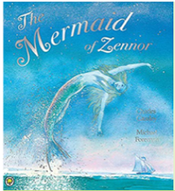 | 3 week unit  Myths/Legends | 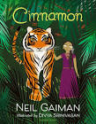 | 3 week unit  Narrative from another culture | 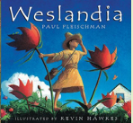 | 3 week unit  Non-Chronological Report
 | 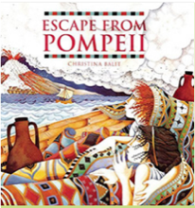 | 3 week unit  Newspaper Article | 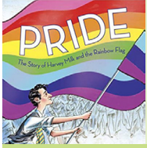 | 2 week unit  Biography/Autobiography | 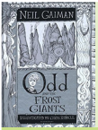 | 3 week unit  Narrative from other perspective
 | 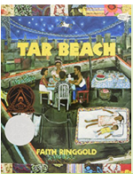 | 3 week unit  Playscript | 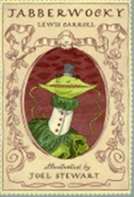 | 2 week unit  Nonsense poetry | 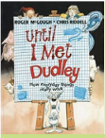 | 2 week unit  Explanation text
 | 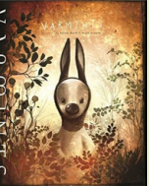 | 3 week unit  Explanation Text | 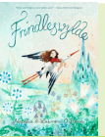 | 3 week unit  Whole school fairytales | 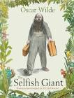 | 3 week unit  Extended narrative
 | 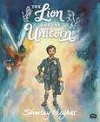 | 3 week unit  Historical |  |  | 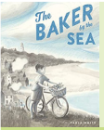 | 3 week unit  Persuasive writing
 |  | Whole school fantasy  2 week unit |  |  |  | Whole School  Community  2 weeks
Maths

 |  | Autumn 1 | Autumn 2 | Spring 1 | Spring 2 | Summer 1 | Summer 2
Science |  | What’s that sound | Living Things | Looking at States | Teeth and Eating | Power it up | The big build
Geography |  | Countries of Europe Comparison of Italy and UK |  | Economic activity with a focus on Italy and UK |  | Climate
History |  | Romans |  | Saxons & Vikings |  | Ancient China
Religious Education |  | Expressing joy, Being thankful, Being reflective, Being curious |  | Being modest, Creating inclusion, Being merciful, Responding to suffering |  | Living by rules, Being temperate, Being imaginative & exploratory
Physical Education |  | Swimming or | Swimming or | Swimming or | Swimming or | Swimming or | Swimming or
Art and Design |  | Collage: use coiling, overlapping, tessellation, mosaic and montage  Matisse, Brianna McCarthy |  | Sculpture: use mouldable materials with texture to express feelings of movement  Keith Haring, Giacometti, Joseph Chandler |  | Textiles: create weavings with cross stitch and backstitch  Lucy Sparrow, Zaha Hadid, Faith Ringgold
Design Technology |  | Mechanical systems: pneumatics or levers and linkages |  | Electrical systems: simple programming and control |  | Food: Healthy and varied diet
Computing | CS |  | Minecraft 1 | Scratch Game Developers | Sphero 2 | HTML Code | Coding Puzzles
 | DL | The Internet
 | OS | Be Internet Legends: Kind 1 | Be Internet Legends: Kind 2 | Be Internet Legends: Kind 3 | Be Internet Legends: Kind 4 | Be Internet Legends: Kind 5 | Be Internet Legends: Brave summary
 | IT | Create Drawing: Architectural design | Create Photo: Action | Create Music: Rhythm and Beat | Create Film: Tutorialas | Animate: Book 3 challenge 1 and 2 | Create Publishing Project
Music |  | Body and tuned percussion | Rock and roll | Changed in pitch, tempo and dynamics | Haiku, music and performance | Samba and carnival sounds and instruments | Adapting and transposing motifs
French |  | Talking about myself and Counting | Birthdays and celebrations | Description and appearance |  | Clothing and French uniform
PSHE and RSE |  | Setting ground rules  Family and relationships 1, 2, 3,  6, 8  PCSO inputs | Health and wellbeing 1, 3, 4, 5  Anti bullying week – family and relationships L4  Road safety week | Economic wellbeing 1, 2, 3, 5  Mental health awareness week – health and wellbeing L7 | Citizenship 1, 2, 4, 5  PCSO inputs | Safety and the changing body 1, 2, 3, 4, 6, 7  Mental health awareness week | Safety and the changing body 8  Families and relationships 6, 7  PCSO inputs  Transition
Safeguarding |  | What should you do if someone hurts your body or hurts you mentally? |  | Why is having a weapon bad and what could happen if you are caught with a weapon?
No Outsiders |  | Dog’s Don’t to Ballet: To know when to be assertive | King and King: understand why people choose to get married | The Way Back Home: To overcome a language barrier | The Flower: To ask questions | Red: a crayon’s Story: To be who you want to be | Transition Module
Enrichment |  | Anti-bullying week  Black History Month  Pantomime  World Children’s Day  Wroxeter Roman City |  | Mental Health and Wellbeing Week  Science Week  Easter Activities at Erdington Baptist Church  Birmingham Central synagogue visit  Sculpture workshop at Herbert Art Gallery |  | Aspirations Week  My Money Week  Art Week  Bridges, Maths and Design workshop
Parent/Carer Engagement

Year 5 Overview
 | Autumn |  | Spring |  | Summer
Reading
Writing | 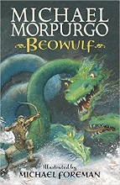 | 3 week unit  Myths and Legends | 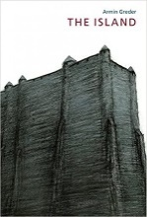 | 3 week unit  Narrative from another perspective | 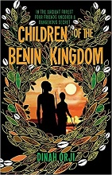 | 3 Week Unit  Non-Chronological Report
 | 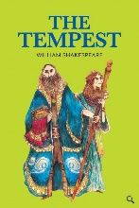 | 2 week unit  Playscript | 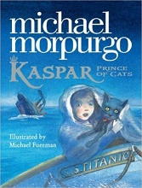 | 3 week unit  Newspaper Article | 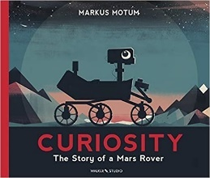 | 3 Week Unit  Explanation Text
 | 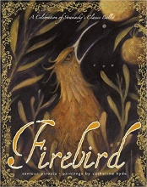 | 3 week unit  Stories from Other cultures | 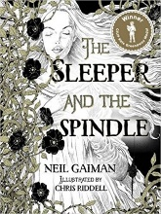 | Whole School  Fairytales  3 week unit | 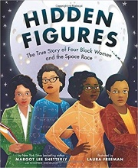 | 3+ Week Unit  Diary/Memoir
 | 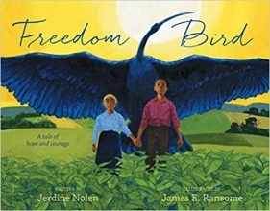 | 3 week unit  Biography |  |  | 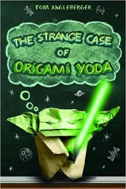 | 3 Week Unit  Balanced Argument
 | 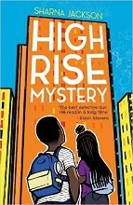 | 3 week unit  Extended Narrative |  |  |  | Whole School  Community  2 week unit
Whole School
Fantasy
2 week unit
Maths

 |  | Autumn 1 | Autumn 2 | Spring 1 | Spring 2 | Summer 1 | Summer 2
Science |  | Out of this world | Material World | Lifecycles | Forces of nature | Growing up and growing old | Amazing changes: reaction
Geography |  | Human and Physical Geography of North America (With climate zones) link to Tudor exploration |  | Rivers (Indus and Thames) |  | Environmental sustainability- Water world (plastics)
History |  | Tudors |  | Victorians (incl. local history study) |  | Benin (West Africa)
Religious Education |  | Caring for others, Sharing & being generous Being loyal, Being hopeful & visionary |  | Being open & honest, Being attentive, Participating, Being modest |  | Being temperate, Being accountable, Being thankful, Being imaginative
Physical Education |  | Dance | Gymnastics | Net/wall games | Invasion games | Striking and fielding | OAA
Art and Design |  | Painting: combine colours, tones and tints to enhance mood and create texture  Georgia O’Keefe, Nerys Levy |  | Sculpture: use tools to carve and add shapes, texture and pattern  Grayson Perry |  | Digital media: use editing to enhance  Jackson Pollack, Peter Thorpe
Design Technology |  | Frame Structures |  | Food: Celebrating culture and seasonality |  | Electrical Systems: Monitoring and control and complex switches and circuits
Computing | CS |  | Minecraft 2 | Sphero 3 |  | Coding Puzzles 2 | Lego Prime
 | DL | Sharing Information |  |  | Data and Communication
 | OS | Be Internet Citizens: 3 sides to every story 1 | Be Internet Citizens: 3 sides to every story 2 | Be Internet Citizens: 3 sides to every story 3 | Be Internet Citizens: Emotional Manipulation 1 | Be Internet Citizens: Emotional Manipulation 2 | Be Internet Citizens: Us vs them 1
 | IT | Create Drawing: Logos | Create Photo: Collage competition | Create Music: Song | Create Film: documentaries | Animate Book 3 Challenge 3, 4 & 5 | Create Publishing Project
Music |  | Composition Notation and Blues |  | Looping and Re-mixing and Musical Theatre |  | South and West African composition to represent the festival of colour
French |  | Sports and Hobbies |  | My Family |  | Introduce and describe friends and family
PSHE and RSE |  | Rule Setting  Family and relationships 1, 3, 4, 5, 7, 8  PCSO inputs | Health and wellbeing 2, 3, 5  Road safety week  Anti bullying week – family and relationships L6 | Economic wellbeing 1, 2, 3, 4, 5  Health and wellbeing 1, 4  Mental health awareness week | Citizenship 1, 2, 3, 5  PCSO inputs | Safety and the changing body 1, 2, 3, 4, 5, 6  Mental health awareness week | Safety and the changing body 6, 7  Economic wellbeing 6  PCSO inputs  Transition
Safeguarding |  | Is it ever okay for someone to touch you in your ‘private parts’? |  | Banter – is it ever okay to make a comment about sexual orientation, appearance, religion etc? |  | What is knife crime?
No Outsiders |  | Where the Poppies Now Grow: To learn from the past | Rose Blanche: To justify my actions | How to Heal a Broken Wing: To recognise when someone needs help | The Arist Who Painted a Blue Horse: To appreciate artistic freedom | And Tango Makes Three: To accept people who are different from me | Transition Module
Enrichment |  | Anti-bullying week  Black History Month  Pantomime  World Children’s Day |  | Mental Health and Wellbeing Week  Science Week  Easter Activities at Erdington Baptist Church  Hindu temple visit- Shree Geeta Bhawan  Victorian Workhouse workshop  Cadbury Victorians talk – model employers |  | Aspirations Week  My Money Week  Art Week  Whitemoor Lakes Residential
Parent/Carer Engagement

Year 6 Overview
 | Autumn |  | Spring |  | Summer
Reading

Writing | 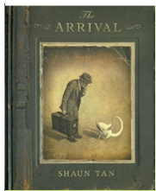 | 3 week unit  Extended Narrative | 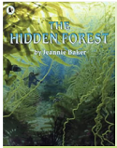 | 3 week unit  Balanced argument | 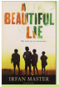 | 3 week unit  Narrative from another culture
 | 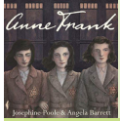 | 2 week unit  Newspaper article | 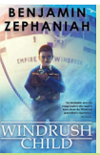 | 3 week unit  Persuasive writing |  | 3 week unit  Playscript
 | 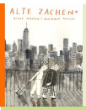 | 3 week unit  Discussion text | 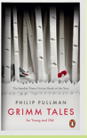 | Whole school  3 week unit  Fairytales | 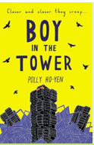 | 3 week unit  Extended narrative
 | 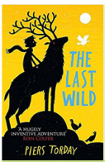 | 3 week unit  Dystopian Narrative |  |  | 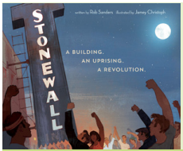 | 3 week unit  Informative text
 | 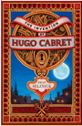 | 3 week unit  Biography |  |  |  | Whole School  2 week unit  Community
Whole school
2-week unit
Fantasy
Maths

 |  | Autumn 1 | Autumn 2 | Spring 1 | Spring 2 | Summer 1 | Summer 2
Science |  | Classifying living things | Healthy bodies | Evolution and Inheritance | Light | Electricity | The Titanic
Geography |  |  | Human and Physical geography of South America | Biomes and vegetation belts (Brazil) |  | Distribution of natural resources and economic activity (Brazil)
History |  | WW2 |  | Black and British |  | Beyond Face Value
Religious Education |  | Living by rules, Being fair, Creating unity, Creating inclusion |  | Remembering roots, Being courageous, responding to suffering, Being merciful |  | Expressing joy, Appreciating beauty, Curious & valuing knowledge, Being reflective and self critical
Physical Education |  | Dance | gymnastics | Net/wall games | Invasion Games | Striking and fielding | OAA
Art and Design |  | Printing: layers of colour creating accurate patterns with fine details  Paul Nash, Henry Moore |  | Collage: ceramic mosaic techniques  Dolan Geiman, Suzanne Siegle, Georges Braque, Jules Anson |  | Textiles: create a range of stitching techniques  Sikhism (Puhlkari)
Design Technology |  | Food: Celebrating culture and seasonality |  | Electrical systems: cams, pulleys and gears |  | Textiles: Using computer aided design and combining different fabric shapes
Computing | CS | Computing systems and Networks | Web Page Creation | Variables in games |  | Coding puzzles 3
 | DL |  |  |  |  |  | Computers, past, present and future
 | OS | Be Internet Citizens: Us vs them 2 | Be Internet Citizens: Haters Gonna Hate 1 | Be Internet Citizens: Haters Gonna Hate 2 | Be Internet Citizens: Creators for Change 1 | Be Internet Citizens: Creators for Change 2 | Be Internet Citizens: Creators for Change 3
 | IT | Create Draw: Infographics | Create Photo: Publishing |  | Create Film: Short film production | Animation: shorts | Create Publishing Project
Music |  | Songs of WW2 | Advanced rhythms | Dynamics, pitch and texture | Film music | Theme and variations | Composing and performing a leavers song
French |  | Shops and Markets | Travel conversation | Healthy lifestyles |  | French around the world
PSHE and RSE |  | Ground rules  Family and relationships 1, 3, 4, 5, 6  PCSO inputs | Health and wellbeing 1, 3, 4, 5, 6  Anti bullying week  Road safety week | Citizenship 1, 2, 3, 4  This is me week – health and wellbeing L7  Mental health awareness week | Economic wellbeing 1, 2, 3, 4  PCSO inputs | Safety and the changing body 1, 2, 3, 4, 5, 6  Mental health awareness week | Health and wellbeing 6, 7  Identity 1, 2  PSCO inputs  Transition
Safeguarding |  | What should you do if one of your peers hurts you or is disrespectful to you? |  | How can knife crime impact the lives of children and young people? |  | What is joint enterprise?
No Outsiders |  | My Princess Boy: To promote diversity | The Whisperer: To stand up to discrimination | The Island: To challenge the causes of racism | Love You Forever: Consider how my life might change as I grow | Dreams of Freedom: To recognise my freedom | Transition Unit
Enrichment |  | Anti-bullying week  Black History Month  Pantomime  World Children’s Day  WW2 Workshop  Cosford AIrfield |  | Mental Health and Wellbeing Week  Messy Science Week  Easter Activities Erdington Baptise Church  France Residential |  | Aspirations Week  My Money Week  Art Week  Buddhist Maha Vahara visit  T20 Cricket match  Drayton Manor Park and Zoo
Parent/Carer Engagement

