Behaviour Policy
2023-24

Our Key Principles

Our Mission
It is our mission to nurture the children of Osborne Primary School, to enable them to grow and reach their full potential. Team Osborne is committed to developing resilient, happy, proud children who love learning and have the skills, knowledge and confidence to achieve their dreams.
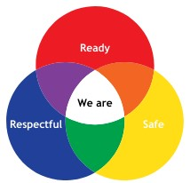
Our Rules:
Ready: We are ready to listen, ready to learn. We are ready for new challenges. We show each other how we are ready every day.

Respectful: We are respectful to everyone we meet in school. We use kind words and welcome everyone. We listen to other’s opinions and share ours in a safe way. We respect our school and look after school property.

Safe: We are safe and keep each other safe. We have kind hands, feet and words. We think about where we are and make smart choices with our actions. We recognise when we feel unsafe and speak to an adult.

At Osborne Primary School we have:
- a safe, comfortable and caring environment where our best learning takes place
- clear guidance for our children, staff and parents of expected behaviour
- a consistent and calm approach

Our behaviour policy helps us to learn:
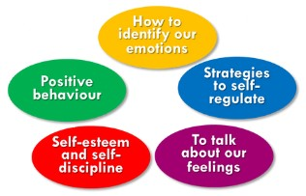

Zones of Regulation:
This is a common language for describing feelings and emotions. It is a system which categorises the complex feelings and states that children experience. It improves the ability to recognise and communicate feelings in a safe and non-judgmental way.

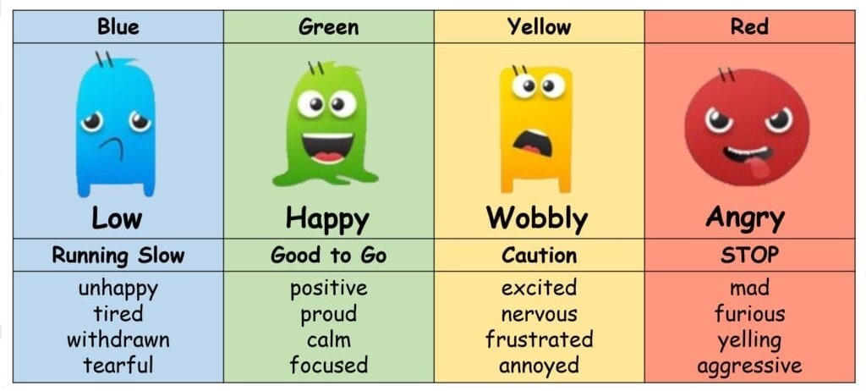

The zones help children to recognise and describe their feelings more easily.

A high state of alertness, though with more control and emotions
A calm state of alertness. May be happy, focus, content and ready to learn.
A very high state of alertness and strong emotions, more difficult to control.
Low states of alertness and down feelings such as feeling sad, tired, sick or bored.

We’ve adopted the principles of the Zones of Regulation so that we have:
- a shared vocabulary for emotions
- support to be calm and ready for learning
- time to be reflective about emotions and communicate better with adults and peers
- ways to reduce escalation quickly
- positive relationships between pupils and staff

Osborne adopts Emotion Coaching through daily practice which involves:

Our children learning about the work of emotion in the moment
Our children having the strategies and tools to self-regulate
Accepting and not disapproving emotions where dysregulation is displayed
Our children building trust and respectful relationships with staff and peers

The 5 Steps to Emotion Coaching are:
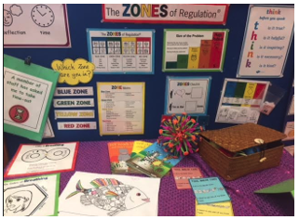
The Classroom Environment:
All classrooms have a calm area which our children are encouraged to use when they are dysregulated. This is supported by the pastoral team and includes:
- Use of the Zones of Regulation resources
- Support to self-regulate outside of the classroom
- The five steps of emotion coaching
- Reflect and Repair – completing a reflection sheet which is filed for future reference
- Parent/s are invited for a meeting to discuss their child’s needs if Reflect and Repair takes place three times in a week
- Reflect and Repair is used when consistent negative behaviours occur, if unsafe behaviour is displayed or if a child is disrespectful to their peers or to adults

If a child needs additional support to regulate their emotions safely:
A senior leader will support using emotion coaching

A suitable space will be identified to aid self-regulation

Where persistent behaviour continues, the child will work on their own with a member of staff for the rest of the day or the following morning necessary

The parent/s will be informed of the incident and actions will be noted
Two trained staff members will use manual handling if necessary
A staff member will use de-escalation techniques to reduce anxiety
- Following the Initial Visit – six weeks of failed contact CME
- Two failed attempts to contact the family to complete an Interim Visit CME
- At the Initial Visit, clear expectations are given
a. At the first Interim Visit at 3-6 months the work is unsatisfactory and recommendations are made
- At the second Interim Visit after a further month there is a failed attempt to make contact, the SOEHE leaves a calling card and message to make contact within a week, and there is no response CME
- Recommendations are made with evidence (photograph) on the second Interim Visit, and they are not followed CME
- If the parent changes their mind or says they cannot continue to home educate CME
- If some education is provided but it is not equivalent to a full-time education, and recommendations are made but not followed CME
What constitutes EHE?
The parent must independen-tly express an intention to take full responsibility for the child’s education.

If the parent expresses this intention they must be encouraged to keep their child on roll and given the opportunity to make an informed decision by speaking with the SOEHE.

Where a parent expresses that they will not be applying for YR or Y7 place it is necessary to check that they intend to take full responsibility for their child’s education.

It is not necessarily EHE when:
The child has been removed from school and is awaiting an alternative school place.

The parent makes it clear they have no means to home educate the child.

A traveller family advise that their child will no longer be attending school, but state that they have no means to home educate the child.

EHE Referral to CME

The child is registered as EHE on Capita One and an electronic file is opened

An Annual Visit or Report continues each year after the Initial Visit

An Annual Visit or Report is carried out 1 year after the Initial Visit

An Interim Visit is carried out 3-6 months after the Initial Visit
The SOEHE arranges a three-way meeting with the child’s school if necessary

The SOEHE carries out an Initial Visit with the parent to discuss the implications of EHE

Where a child displays ongoing dysregulation and is not ready, respectful or safe, the school will work with outside agencies to support the child and family’s needs.
This includes:
City of Birmingham School (COBS) the local authority Pupil Referral Unit

Beyond Horizon Play Therapy

Cherish Focused and Trauma Responsive Support

In the event that a child continues to display dangerous behaviour and there are safeguarding concerns for them and others, the following action will be taken:
A suspension/exclusion will be issued

+

Please see ATLP’s Suspensions and Exclusions Policy
https://atlp.org.uk/files/2023/11/Exp-2025-09-Suspensions-and-Exclusions-Policy-v3.pdf#suspensions-and-exclusions-policy/

A work pack and online learning links will be sent home

On return to school, the child and parent will attend a reintegration meeting

Pastoral support will be put in place through mentoring and nurture support

Support from external agencies is offered to the family

For all of our children, Osborne should be a safe and welcoming place where they can achieve success. We celebrate the nationality and ethnicity of everyone in our school family and take racism and discrimination seriously. Racism is harmful and our approach to it, detailed in our Bullying Policy and Equality Policy, is:

The parent/s of the child who has harmed will be invited for a meeting on the same day. The Anti-Racist policy will be discussed.

The child who has harmed will work away from the classroom with a member of the senior leadership team for an agreed period.
The child who has harmed will be supported to understand why racism is unacceptable in Osborne Primary School and the wider world.
The child who has been harmed will be supported by the pastoral team and their parent/s will be informed of the incident.

The child who has been harmed will receive ongoing support from the pastoral team and their parent/s informed.

My Concern:
Behaviours that do not align with our mission statement and school rules are added to My Concern. A designated safeguarding lead monitors this portal.

