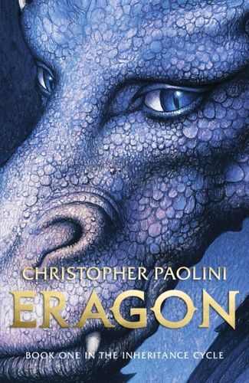  Eragon |  | 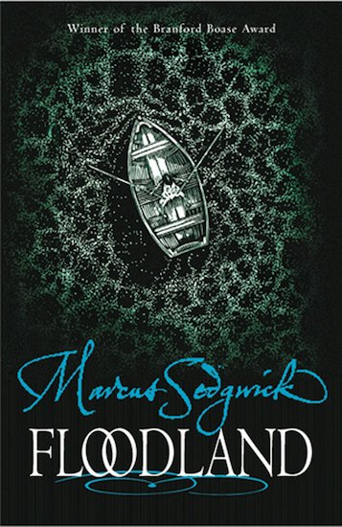  Floodland
Diary Entries | Fantasy Stories | Persuasive Writing | Explanation Text
Identify the features of a range of recounts.  Identify structural features of recounts.  Develop settings using expanded noun phrases and precise figurative language.  Use brackets appropriately | Use a range of strategies to create tension e.g short sentences.  Develop settings using expanded noun phrases and precise figurative language.  Develop characterisation by showing the reader what characters say and do and how they feel and react at different points in the story | Identify from reading persuasive words and phrases and strategies used to persuade.  Draft and write a persuasive letter for a real purpose.  Structure argument to include two key points in support for main point.  Use persuasive words and phrases  Use language devices such as rhetorical questions.  Use modal verbs for effect. | Use structure: introduction, followed by sequential explanation, organised into paragraphs.  Use of diagrams and other illustrations, subheadings, numbering.  Use causal and temporal connections (e.g. while, during, after, because, as a result, due to, only when, so)  Use hypothetical language (if...then, might, when the...)

