Home Learning 30.3.22
Maths
Carry on with the 3d shape activities on Oak Academy from yesterday

Literacy & SPaG
Relative Pronouns/Clauses
Watch Oak Academy
https://classroom.thenational.academy/lessons/to-explore-relative-clauses-65k30c
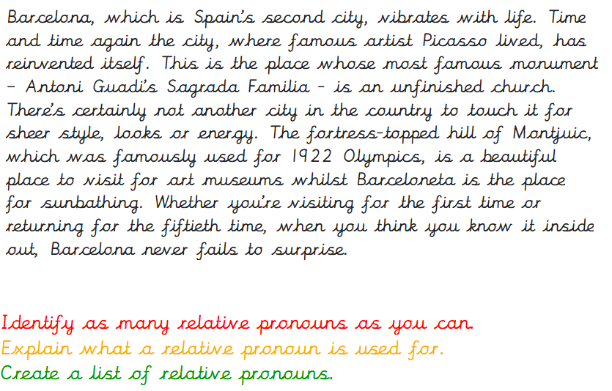
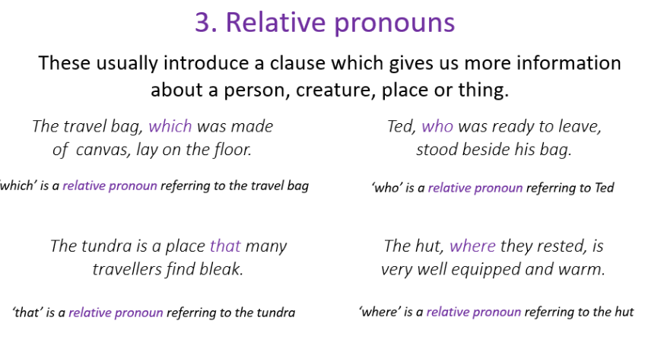
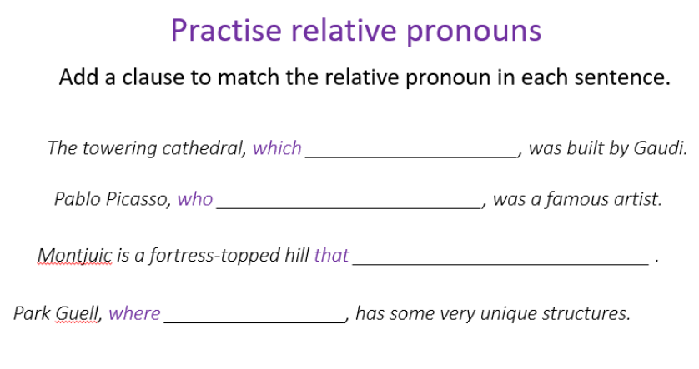
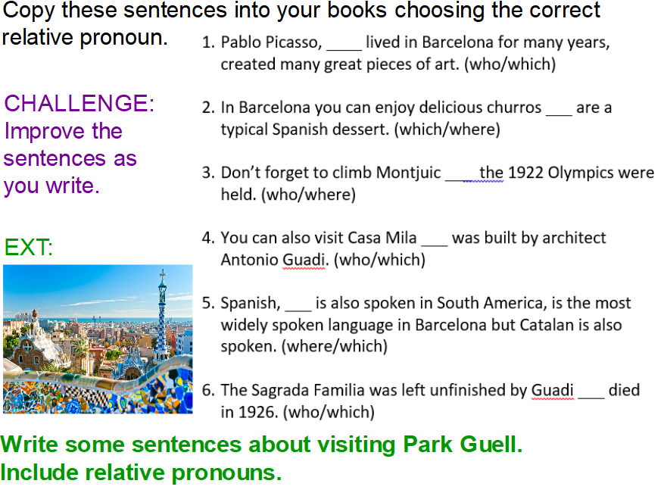

Guided Reading
ICT Reading
Go on Reading Plus

Maths Fluency
Practice Times Tables on TTRS (all tables – Cristian is not secure on all his tables)

PATHs
This is done in school by an outside provider so Cristian will not be able to participate. It might be useful for him to go on Oak Academy and watch some of the English Grammar activities

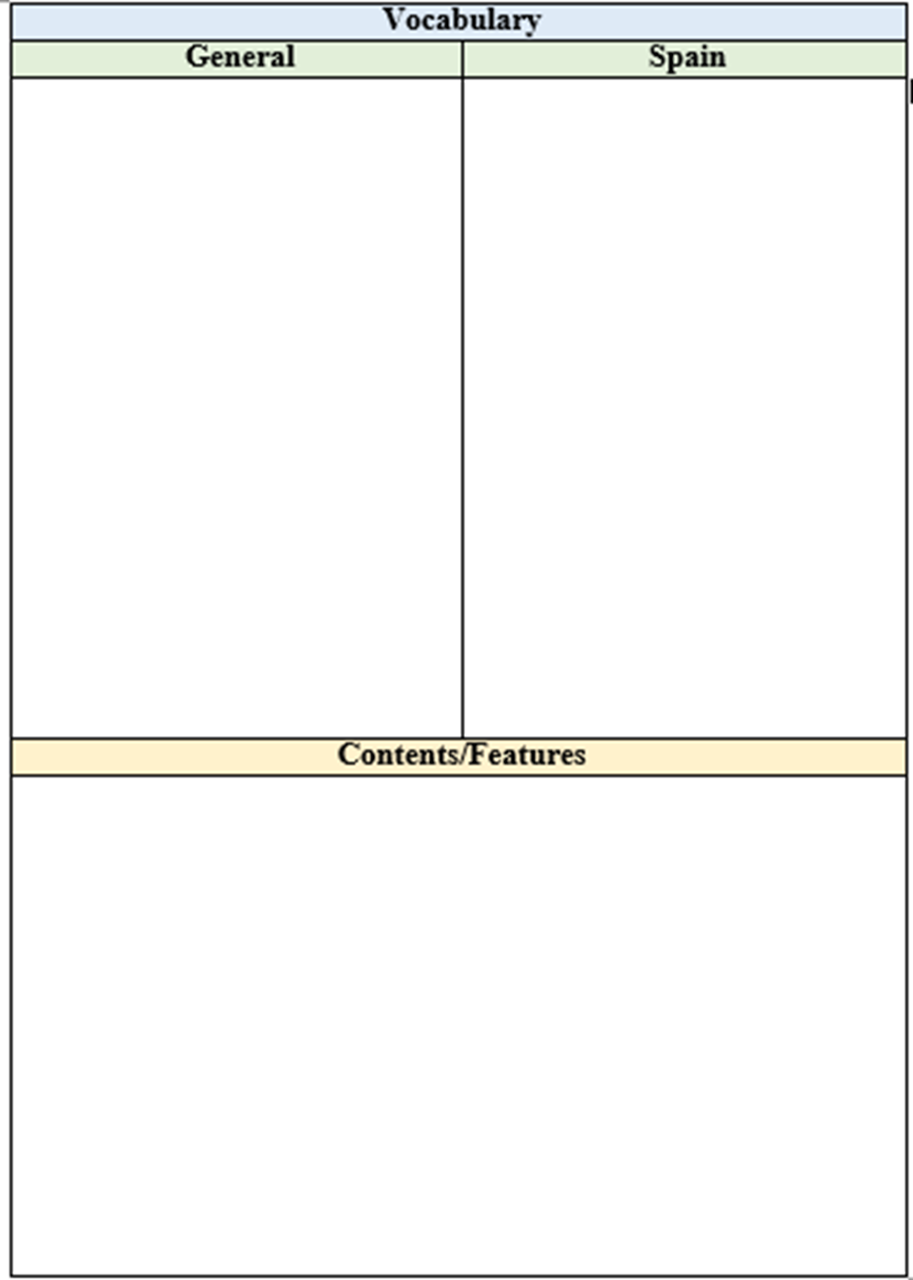
Guided Reading
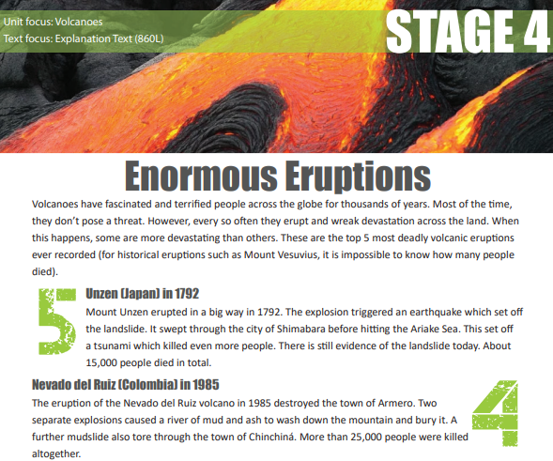
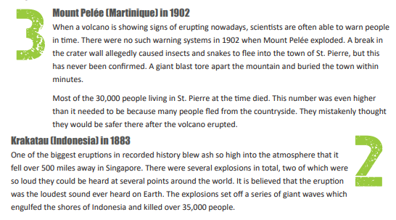
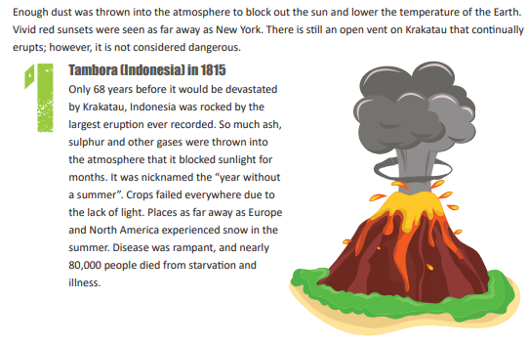
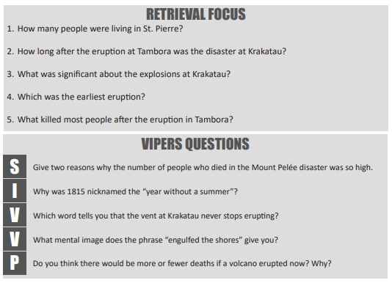

Maths Fluency
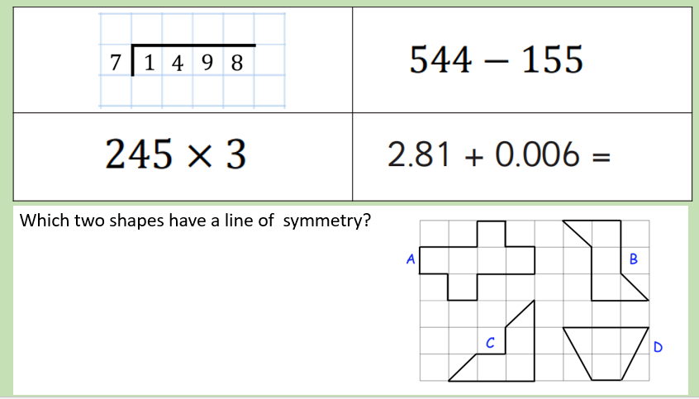
Music
To sing in cannon
Oak Academy lesson
https://teachers.thenational.academy/units/harmony-cf55

We are also learning a song for Mrs Gay’s farewell assembly
The song is:Hannah Montana “I’ll Always Remember You”. (Can be found on You Tube)
Please practice.

