Autumn 2021 – Home learning project
Topic – How we used to live
This term, we will be exploring the Anglo Saxons and the Vikings as part of our cross-curriculum topic ‘How we used to live’.
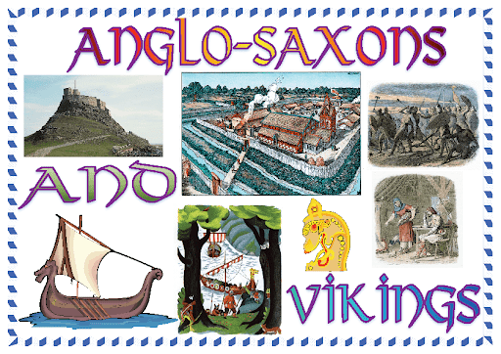
Your project this term is to create a piece of work to display your research and understanding of the Anglo-Saxons and the Vikings. Here are some ideas for the kind of project that you could create:
- Multimedia Poster
- PowerPoint presentation
- Video / movie / documentary
- Leaflet about Anglo Saxon life
- Model of a Viking village
- Or any other creative ideas you can think of!
You will be sending your project to your class teachers via email at the end of the autumn term, so a digital project would be best where possible. But please do not let that limit you! If you have a great idea for something that you will create without the use of a computer, you can always take pictures of your fantastic project and send them in.
Please see the next page for some recommended websites and reading to get you started.
BBC Bitesize – Who were the Anglo Saxons? https://www.bbc.co.uk/bitesize/topics/zxsbcdm/articles/zq2m6sg
BBC Bitesize – When did the Anglo Saxons come to Britain? https://www.bbc.co.uk/bitesize/topics/zxsbcdm/articles/z23br82
BBC Bitesize – What happened to the Anglo Saxons and the Vikings? https://www.bbc.co.uk/bitesize/topics/zxsbcdm/articles/z8q487h
National Geographic Kids - Awesome Anglo Saxon facts! https://www.natgeokids.com/uk/discover/history/general-history/anglo-saxons/
National Geographic Kids – 10 facts about the Vikings https://www.natgeokids.com/uk/discover/history/general-history/10-facts-about-the-vikings/

Books:
Anglo Saxons https://schoolreadinglist.co.uk/books-for-topics/anglo-saxons/
Vikings https://schoolreadinglist.co.uk/books-for-topics/vikings/

