PE is on Wednesday
Home Learning Opportunities
Class: Year 3
Learning activities set and sent home on: 1st October
To be completed and returned by the: 6th October
Literacy Learning Opportunity: Descriptive writing.
Guidelines: Imagine you are in the Amazon Rainforest –what can you see, hear, touch, taste
or smell?
Independent or with support: Independent – We have been researching about the Rainforest and reading a book called ‘The Explorer’.
Skills Checklist: Use adjectives when describing.
Use adectives – green enormous screeching rustling wet damp sweet crunchy hot
ICT : Reading Egg Activities – https://readingeggs.co.uk/

Maths Learning Opportunity: Comparing and ordering numbers

Guidelines: Reinforcing the value of each digit in a number
Independent or with support: Independently so that your teacher can see where you may require some help.
Skills Checklist: Understanding the value of each number – Hundreds, Tens, Ones
ICT: Times Tables Rock Stars – https://ttrockstars.com/

Home Learning Project
We would like you to create a shoe box South American rainforest model linked to our
Geography topic. This does not need to be completed until the end of term. You can do a small amount each week. Please do not leave it all until the last week.
Possible things you could use: shoe boxes, cardboard boxes, string, bottle tops, buttons, paint, crayons, glitter, card and glue – feel free to use whatever you like though.
Image Ideas: Week 1 – Find a box or show box. Paint the base colour.
Week 2 – Create land structures such as hill, river waterfall. Use cardboard ,bubble wrap from packaging, sweet wrappers, paint and felt tips. Have fun!
Week 3 –Make trees, grasses, shrubs, hanging vines and plants. Use tubes, straws, wool, string, tissue, paper. Enjoy yourself!

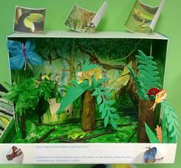
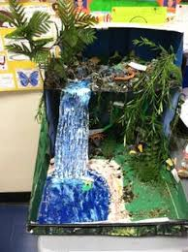

THERE ARE 1000s OF IDEAS OF HOW TO MAKE THESE ON THE INTERNET.

Year 3 writing home learning

Describe your visit to the Amazon Rainforest.
What can you see, hear, touch, taste and smell?
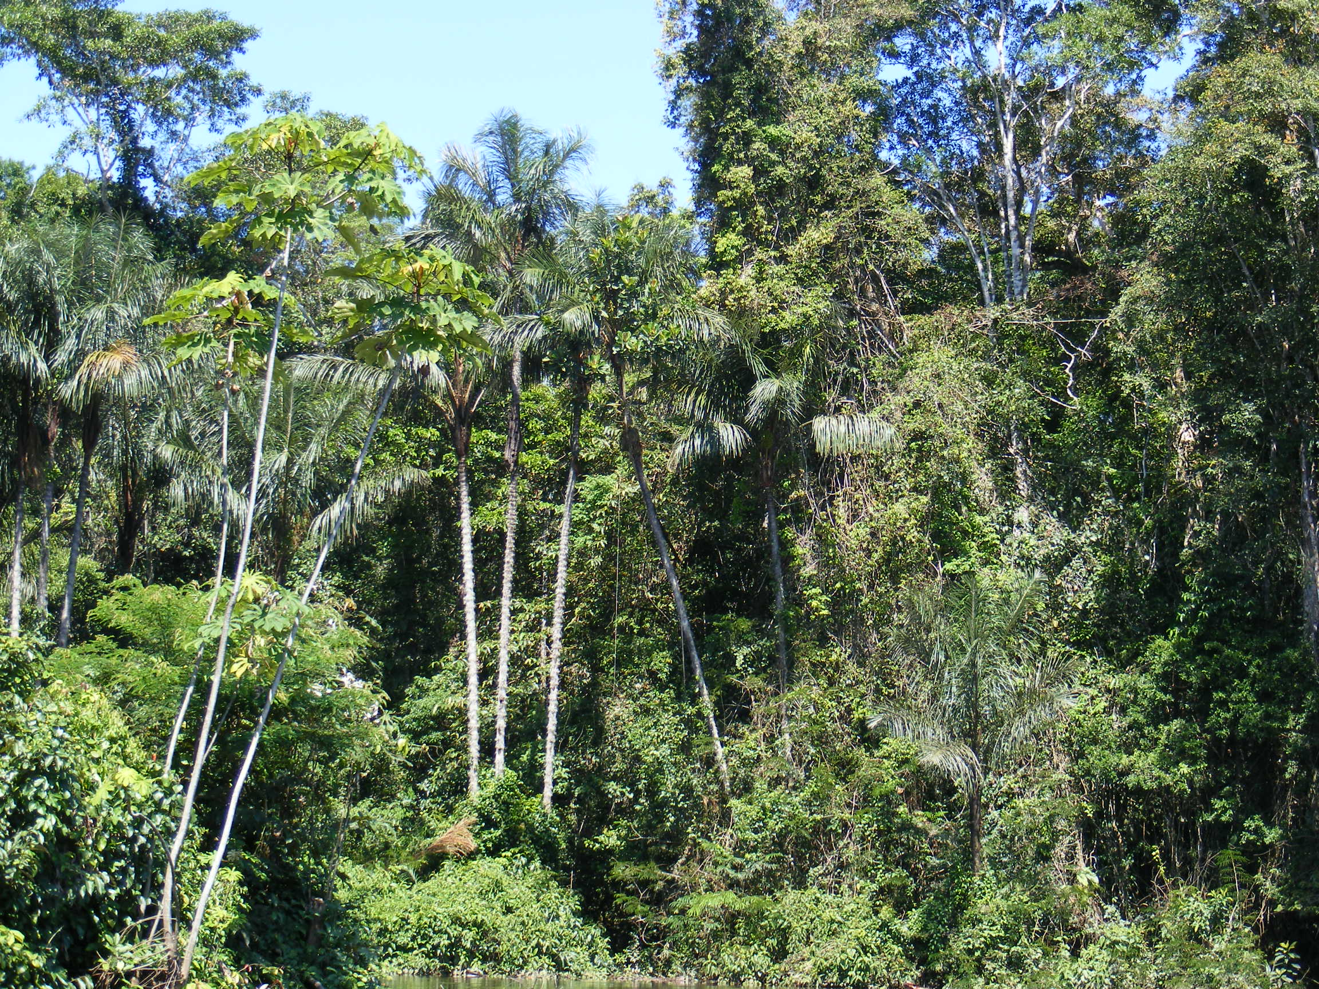
Remember to use adjectives – describing words.
_________________________________________

_________________________________________

_________________________________________

_________________________________________

_________________________________________

Maths: Quick Questions (Give it a go!

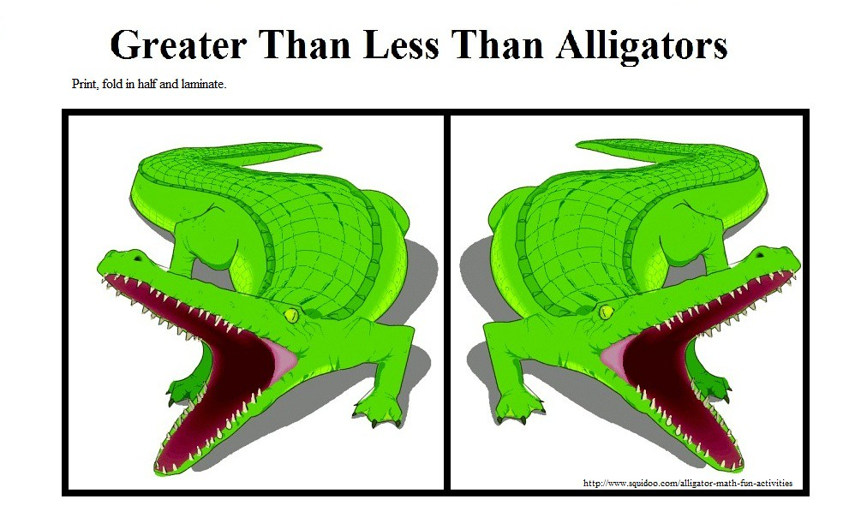Use the greater than and less than signs to complete the calculations.

1. 47 82 2. 92 36
3. 562 235 4. 781 572
5. 300+30 +9 500+20+7
6. 800+ 70+ 1 300+40+6
7. 500+60 +9 500 + 60 + 6
8. Complete the number ordering lines.

60 |  | 80 |  | 100

15 | 20 |  | 30

9. Which numbers in each sequence are wrong.
10 | 20 | 25 | 40 | 50

35 | 40 | 44 | 50 | 55

12 | 13 | 16 | 18 | 20

10. Create your own number sequences. You can count in 2s, 5s, 10s, 50s, 100s .

Great Work!

